WITNESS PROGRAMS 2011:
Contra Dances—6 dances were held on the second Friday of the month from October through March. We had good attendance at some (over 40 at the one in January) not so good at others. We need to get more Centralites coming to the dances—they are both for Centralites and to introduce new folks to the church. We have received high praise for the dances, and several donations to help offset the cost of the dances including from the Ann Arbor Council for Traditional Music and Dance, which would like to see this series in downtown Detroit become well-established.
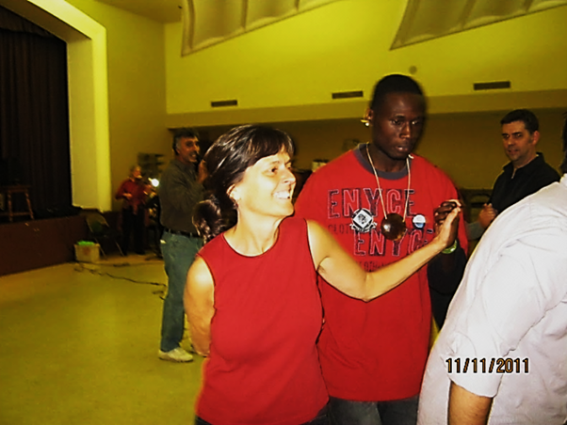
Merry TubaChristmas. This was our second year and we about doubled both the audience and the tuba players. We took in over $700 in the offering. We did have to move the concert from Dec. 11 to Dec. 16 due to a Lion’s game. Unfortunately our guest conductor, G.R. Davis from Nashville, fell during rehearsal and had to be taken the hospital. Luckily Victoria Miller, director of bands at Martin Luther King H.S. was in the audience and agreed to take the baton. G.R. was fine and even drove home that night. He will be back this year on Dec. 16 for what has become a Central Christmas tradition.
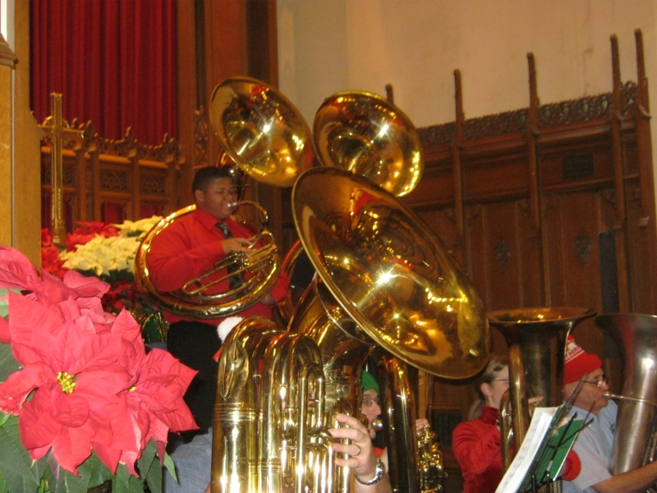 | 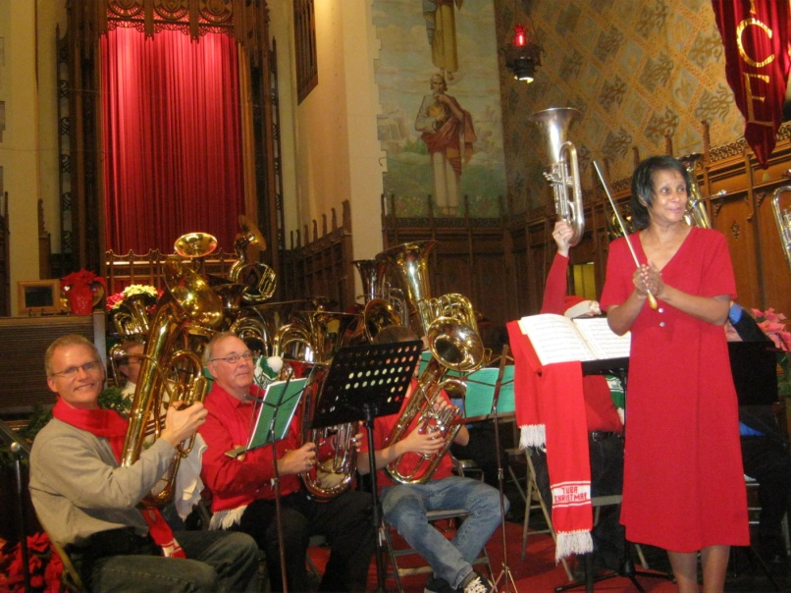

Jim Bull

