CENTRAL UNITED METHODIST CHURCH
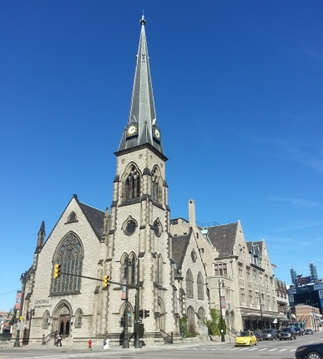
23 E. Adams, Detroit, MI 48226 313-965-5422 www.centralumchurchdetroit.org
Sunday Service 10:30 a.m. , Church School at 9 a.m.
Rev. Edwin A Rowe, Senior Pastor
Andrew Gladstone-Highland, Alicia Skillman
Pastoral Assistants
Dr. Edward Maki-Schramm, Minister of Music
Nina Scott, Ensemble Director
Bobbi Thompson, soloist and accompanist
Amy Brown, N.O.A.H. Director
Wendy Hamilton, Swords Into Plowshares Center Director

Central United Methodist Church, the first Protestant congregation in Michigan, is a Reconciling Congregation that welcomes all people regardless of economic status, race, gender identification, or sexuality. We have been working for peace with justice in three centuries. We were organized in 1810 (We celebrated our bicentennial in 2010!), incorporated in 1822 and completed the present sanctuary in 1867 (before the advent of electric lights--capped gas pipes for gas lights can still be seen on the walls). We envision Central as a vital, diverse river of life nurtured by the light of Christ, rooted deeply in and living the scripture, a holy presence in the center of Detroit, transforming individuals, institutions and the world, advocating peace and justice in all we do.
Central members were involved in the movement to end capital punishment in Michigan in the mid-1800s. Central was one of the first truly integrated congregations in the Detroit area and has long been involved in the Civil Rights Movement. Dr. Martin Luther King, Jr. often preached at Central, the last time just two weeks before his death. Central pastors have spoken for the pacifist viewpoint since World War II. Dr. Henry Hitt Crane, pastor from 1938-58 was a target of Sen. Joe McCarthy’s witch-hunts. During the Vietnam War Central’s pastor, Dr. James H. Laird was hung in effigy by anti-communist demonstrators. We also housed a draft counseling center during the Vietnam War. Central is often the gathering place for rallies and marches for peace and social justice, and its pastors and congregants have even been arrested for civil disobedience.
Long a proponent of unions and labor negotiation, Central housed the office for striking newspaper workers and currently houses a library/archive devoted to African American history in the union movement. Recently a mission trip went for the second time to Nicaragua to a ministry that helps women with troubled pregnancies. We have also been active in the movement for a moratorium on foreclosures. Current Central ministries include:

N.O.A.H.—Networking, Organizing, and Advocacy for the Homeless which provides a bag lunch two times per week (Tues and Thurs), a social worker, case workers, a nurse, a music educator and visual arts program (“Art and Soul” led by volunteers from Birmingham First United Methodist).

Swords Into Plowshares Peace Center and Gallery (SIP)—an art gallery devoted to relating the arts to imagining the transformation of the world to one of peace and justice.

Grace Paisley Small World Shop—selling handicrafts from the developing world helping artisans get paid fairly for their work and to become self-sufficient. Handicrafts mostly from SERRV, a Mennoite program.

Value Shop—offering quality used items at affordable prices, thus serving those with limited incomes and raising funds for the church.

We sell peanuts at every baseball game, parking lot revenues help maintain our many ministries, we house the National Welfare Rights Organization and Westside Mothers, both of which help people in need get the help they deserve. You are welcome to become part of this multi-cultural, multi-faceted congregation any time you are able. We believe as John Kennedy once said, “On earth, God’s work must truly be our own.”

